UNIVERSITY OF CALIFORNIA, LOS ANGELES
Department of Computer Science

EE M 171L & CS 117

Student name: _____________________

Laboratory Exercise 5 (a,b): Demodulation of AM and FM Signals
(Include with Report)

Theory

1) What are the most important distinctions between envelope detection and synchronous demodulation of an amplitude-modulated signal?

2) What are the two main components of a circuit, which performs envelope detection?

Exercise #5 (a,b): Theory (continued)

3) Draw the block diagram of the Phase-Locked Loop frequency demodulator, and explain the assignment of each block.

When we transmit a digital 0/1 signal and regenerate the signal at the destination, one way to measure the received signal quality is bias distortion. It establishes the timing accuracy necessary for the receiver to accurately read the signal, or the jitter tolerance.
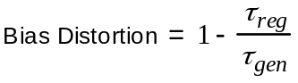
τ_{reg} : pulse width of the regenerated signal (Figure 1)

τ_{gen} : pulse width of the baseband square wave signal (Figure 1)

Exercise #5 (a,b): Theory (continued)
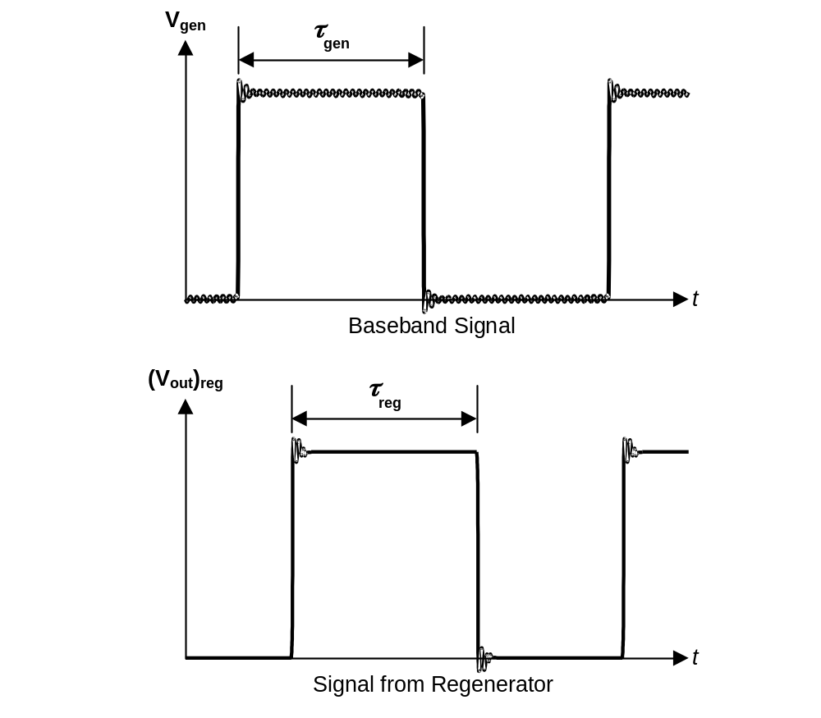Figure 1. Comparing baseband pulse width to regenerated pulse width.

4) If bias distortion is +0.020, what is the duty cycle of the rectangular wave at the regenerator output when the baseband signal is a 1 kHz square wave (pulse width of 500 μs)?

Exercise #5 (a,b): Theory (continued)

5) Using the value of K_{FM} =2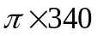, calculate the value of ( Δf_{c} )_{max} for the signal in part C of this lab.

6) What is the formula to calculate the bandwidth BW of a system from its rise time?

7) What is the formula to calculate a system’s channel capacity in bits per second from its bandwidth BW and the signal to noise ratio?

8) What is the bandwidth required to transmit a 2 kbps digital signal with a signal-to-noise ratio of 1?

